**Little Theatre Movement**

The Little Theatre Movement comprised a web of amateur theatre activities undertaken across much of the United States between 1912 and 1925. Little Theatre opposed commercialism; its proponents believed theatre could be used for the betterment of American society and for self-expression. Little Theatre founders and participants included playwrights, professors, liberal political activists, social workers, lawyers, heiresses, poets, actors, aesthetes, journalists, housewives, and students. They drew inspiration from the best-known work of the European Independent Theatre Movement and from the design aesthetics of Adolphe Appia, Edward Gordon Craig, and Max Reinhardt. Eventually their values affected commercial theatre.

The Little Theatre Movement is best known for four of its earliest companies: the Provincetown Players, the Washington Square Players, the Chicago Little Theatre, and the Neighborhood Playhouse. No two of these were alike, suggesting the breadth and variety of the movement’s undertakings. The Provincetown Players started in 1915, when a group of New York-based writers and activists assembled at their summer beach haunt in Massachusetts to present short, original plays. The founders were idealist George Cram Cook and his writer wife, Susan Glaspell; the group is perhaps best known for giving Eugene O’Neill his start as a produced playwright. The Washington Square Players was also started by a group of iconoclastic New Yorkers. The WSP’s mission was not, however, the production of member-written, American plays, but rather the production of a variety of plays from many sources. Both companies broke up over the question of professionalism, a goal that retooled the WSP as the Theatre Guild and sent O’Neill in quest of Broadway. The Neighborhood Playhouse, founded by Irene and Alice Lewisohn, heiresses with a deep interest in the arts, served immigrants at New York’s Henry Street Settlement starting in 1912. Other settlement houses (community centers for immigrants and the underprivileged) with Little Theatre activities included Hull-House in Chicago and Cleveland’s Playhouse Settlement (founded in 1917 and now called Karamu). Maurice Browne’s Chicago Little Theatre favored abstract, rhythmic work and was famous for a production of Euripides’ *The Trojan Women* that toured as an anti-war statement.

The Little Theatre Movement undergirded the creation of the Theatre major in US universities. Again, approaches differed. At Harvard, George Pierce Baker pioneered courses in playwriting, with workshop (‘tryout’) productions at the end of each term. At the University of Iowa, E. C. Mabie started a department of Theatre and Speech in the belief that a state-supported institution serving more than elites needed to provide a means of teaching speaking and expression. Thomas Woods Stevens’s goals at the Carnegie Institute of Technology (now Carnegie Mellon University) included an emphasis on the designed, built, and technical components of modern theatre.

Two highly influential facets of the Little Theatre Movement were its commitment to the New Stagecraft and the journal *Theatre Arts Monthly*. The New Stagecraft eschewed pictorialism and heavy literalism in favor of suggestion and fluidity in design. *Theatre Arts Monthly*, founded by Sheldon Cheney at the Detroit Arts and Crafts Institute in 1916 and published until 1948, would become the main source of nationally shared Little Theatre ideas and ideals.

**References and Further Reading**

Browne, Maurice. (1914) “The Temple of a Living Art.” Chicago Little Theatre.

Chansky, Dorothy. (2004) *Composing Ourselves: The Little Theatre Movement and the American Audience*. Carbondale, IL: Southern Illinois University Press.

Cheney, Sheldon. (1917; 1925) *The Art Theatre: Its Character as Differentiated from the Commercial Theater; Its Ideals and Organization; and a Record of Certain European and American Examples*. New York: Knopf.

Lock, Charles. (1988) “Maurice Browne and the Chicago Little Theatre.” *Modern Drama* 31.1: 106-16.

Mackay, Constance D’Arcy. (1917) *The Little Theatre in the United States*. New York: Henry Holt.

Moderwell, Hiram Kelly. (1914) *The Theatre of To-Day*. New York: John Lane.

“A History of the Provincetown Playhouse.” http://www.provincetownplayhouse.com/history.html.

Sarlós, Robert Károly. (1982) *Jig Cook and the Provincetown Players: Theatre in Ferment.* Amherst, MA: University of Massachusetts Press.

**Dorothy Chansky, Texas Tech University**

**Recommended Illustrations**

**[Please use all four if possible.]**

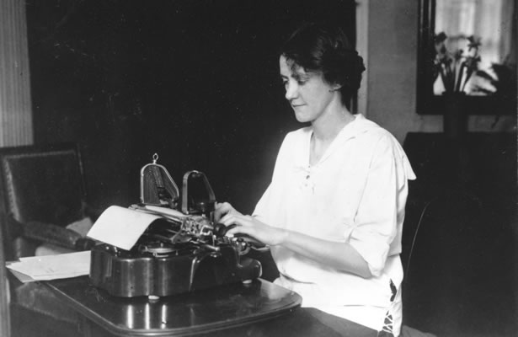

**Susan Glaspell (1876-1948)**

[Available at: <http://www.provincetownplayhouse.com/images/Susan%20Glaspell%20at%20typewriter.jpg>]

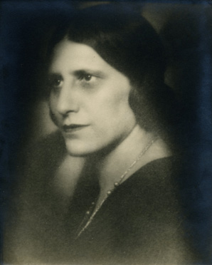

**Irene Lewisohn (1886-1944)**

[Available at: <http://www.metmuseum.org/about-the-museum/now-at-the-met/features/2011/~/media/Images/About%20the%20Museum/Now%20at%20the%20Met/2011/2011_12/MetHistory_121311_4.ashx>]

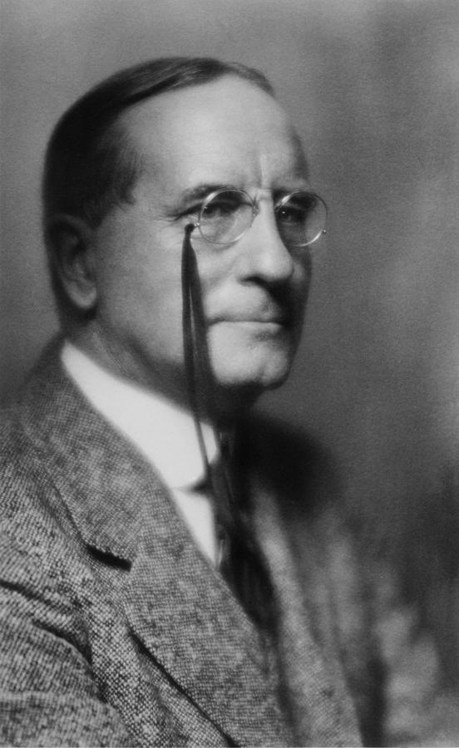

**George Pierce Baker (1865-1935)**

[Available at: <http://images.fineartamerica.com/images-medium-large/george-pierce-baker-1866-1935-taught-everett.jpg>]

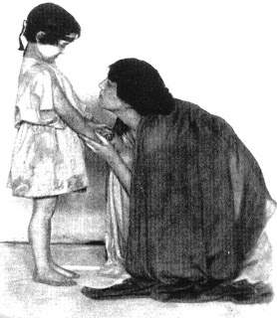

**Kirah Markham as Andromache in *The Trojan Women* at Maurice Browne’s Chicago Little Theatre, 1913.**

[Available at: <http://4.bp.blogspot.com/-p-MoSfMI-j0/UNDBA_ujdkI/AAAAAAAAIXM/Dk-aMsrHmac/s320/Kirah+Markham,+Trojan+Women,+1913.jpg>

The above photo link is on the Southern California Architectural History website (scroll way down the page): <http://socalarchhistory.blogspot.ca/2012_11_01_archive.html> ]